SAFETY DATA SHEET of:
Vira Kill Liquid Hand Sanitiser
Revision date: Monday, March 16, 2020
1 | SECTION 1: Identification of the substance/mixture and of the company/undertaking:
1.1 Product identifier:

Vira Kill Liquid Hand Sanitiser
1.2 Relevant identified uses of the substance or mixture and uses advised against:
/
Concentration in use: /
1.3 Details of the supplier of the safety data sheet:
Wipeout Ltd
Unit 45, Cookstown Industrial Estate
Tallaght, Dublin 24
Phone: 01 451 6666
E-mail: sales@wipeout.ie — Website: http://www.wipeout.ie
1.4 Emergency telephone number:
01 451 6666
2 | SECTION 2: Hazards identification:
2.1 Classification of the substance or mixture:
Classification of the substance or mixture in accordance with regulation (EU) 1272/2008:
H225 Flam. Liq. 2 H319 Eye Irrit. 2
2.2 Label elements:
Pictograms:
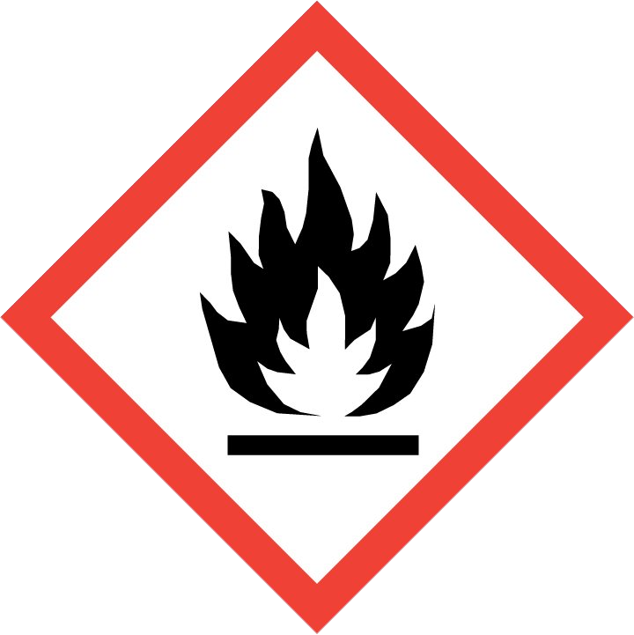
Signal word:
Danger
Hazard statements:
H225 Flam. Liq. 2: | Highly flammable liquid and vapour.
H319 Eye Irrit. 2:  Precautionary statements: | Causes serious eye irritation.
P210: | Keep away from heat, hot surfaces, sparks, open flames and other ignition sources. No smoking.
P305+P351+P338: | IF IN EYES: Rinse cautiously with water for several minutes. Remove contact lenses, if present and easy to do. Continue rinsing.
P337+P313: | If eye irritation persists: Get medical advice/attention.
P370+P378: | In case of fire: Use carbon dioxide (CO2) or dry chemical extinguisher for extinction
P403+P233: | Store in a well-ventilated place. Keep container tightly closed.
P501: | Dispose of contents/container in accordance with local/regional/national/international regulations.
Contains:
Ingredients INCI: Alcohol denat., Aqua, Isopropyl Alcohol, Glycerin, Hydroxypropyl Methylcellulose
2.3 Other hazards:
None
3 |  | SECTION 3: Composition/information on ingredients:
 | Ethanol |  | ≤ 80 % | CAS number: | 64-17-5
 |  |  |  | EINECS: | 200-578-6
 |  |  |  | REACH Registration number: | 01-2119457610-43
 |  |  |  | CLP Classification: | H225 Flam. Liq. 2 H319 Eye Irrit. 2
 | Isopropanol |  | ≤ 5 % | CAS number: | 67-63-0
 |  |  |  | EINECS: | 200-661-7
 |  |  |  | REACH Registration number: | 01-2119457558-25
 |  |  |  | CLP Classification: | H225 Flam. Liq. 2  H319 Eye Irrit. 2  H336 STOT SE 3
For the full text of the H phrases mentioned in this section, see section 16.
4 | SECTION 4: First aid measures:
4.1 Description of first aid measures:
Always ask medical advice as soon as possible should serious or continuous disturbances occur.
Skin contact: | Rinse with water.
Eye contact: | Rinse first with plenty of water, if necessary seek medical attention.
Ingestion: | Rinse first with plenty of water, if necessary seek medical attention.
Inhalation: | In case of serious or continuous discomforts: remove to fresh air and seek medical attention.
4.2 Most important symptoms and effects, both acute and delayed:
Skin contact: | None
Eye contact: | Redness
Ingestion: | Diarrhoea, headache, abdominal cramps, sleepiness, vomiting
Inhalation: | None
4.3 Indication of any immediate medical attention and special treatment needed:
None
5 | SECTION 5: Fire-fighting measures:
5.1 Extinguishing media:
CO2, foam, powder, sprayed water
5.2 Special hazards arising from the substance or mixture:
None
5.3 Advice for firefighters:
Extinguishing agents to be None avoided:
6 | SECTION 6: Accidental release measures:
6.1 Personal precautions, protective equipment and emergency procedures:
Do not walk into or touch spilled substances and avoid inhalation of fumes, smoke, dusts and vapours by staying up wind.
Remove any contaminated clothing and used contaminated protective equipment and dispose of it safely.
6.2 Environmental precautions:
Do not allow to flow into sewers or open water.
6.3 Methods and material for containment and cleaning up:
Contain released substance, store into suitable containers. If possible, remove by using absorbent material.
6.4 Reference to other sections:
For further information, check sections 8 & 13.
7 | SECTION 7: Handling and storage:
7.1 Precautions for safe handling:
Handle with care to avoid spillage.
7.2 Conditions for safe storage, including any incompatibilities:
Keep in a sealed container in a closed, frost-free, ventilated room.
7.3 Specific end use(s):
/
8 | SECTION 8: Exposure controls/personal protection:
8.1 Control parameters:
Listing of the hazardous ingredients in section 3, of which the TLV value is known
Ethanol 1,907 mg/m³, Isopropanol 424 mg/m³
8.2 Exposure controls:
 | Inhalation protection: |  | Respiratory protection is not required. Use ABEK type gas masks in case of irritating exposure. If necessary, use with sufficient exhaust ventilation.
 | Skin protection: |  | Handling with nitril-gloves (EN 374). Breakthrough time: >480’ Material thickness: 0,35 mm. Thoroughly check gloves before use. Take of the gloves properly without touching the outside with your bare hands. The manufacturer of the protective gloves has to be consulted about the suitability for a specific work station. Wash and dry your hands.
 | Eye protection: |  | Keep an eye-rinse bottle within reach. Tight-fitting safety goggles. Wear a face shield and protective suit in case of exceptional processing problems.
 | Other protection: |  | Wear impermeable clothing. The type of protective equipment depends on the concentration and amount of hazardous substances at the work station in question.
9 |  | SECTION 9: Physical and chemical properties:
9.1 Information on basic physical and chemical properties:
 | Melting point/melting range: |  | -48 °C
 | Boiling point/Boiling range: |  | 78 °C — 290 °C
 | pH: |  | 7.0
 | pH 1% diluted in water: |  | /
 | Vapour pressure/20°C,: |  | 5 850 Pa
 | Vapour density: |  | Not applicable
 | Relative density, 20°C: |  | 0.8062 kg/l
 | Appearance/20°C: |  | Liquid
 | Flash point: |  | 18 °C
 | Flammability (solid, gas): |  | Not applicable
 | Auto-ignition temperature: |  | 370 °C
 | Upper flammability or explosive limit, (Vol %): |  | 19.000 %
 | Lower flammability or explosive limit, (Vol %): |  | 2.000 %
 | Explosive properties: |  | Not applicable
 | Oxidising properties: |  | Not applicable
 | Decomposition temperature: |  | /
 | Solubility in water: |  | Completely soluble
 | Partition coefficient: noctanol/water: |  | Not applicable
 | Odour: |  | characteristic
 | Odour threshold: |  | Not applicable
 | Dynamic viscosity, 20°C: |  | 350 mPa.s
 | Kinematic viscosity, 40°C: |  | 434 mm²/s
 | Evaporation rate (n-BuAc = 1):  9.2 Other information: |  | 2.000
 | Volatile organic component (VOC): |  | 78.00 %
 | Volatile organic component (VOC): |  | 628.836 g/l
 | Sustained combustion test : |  | /
10 |  | SECTION 10: Stability and reactivity:
10.1 Reactivity:
Stable under normal conditions.
10.2 Chemical stability:
Extremely high or low temperatures.
10.3 Possibility of hazardous reactions:
None
10.4 Conditions to avoid:
Protect from sunlight and do not expose to temperatures exceeding + 50°C.
10.5 Incompatible materials:
Acids, alkalines, oxidants, reductants
10.6 Hazardous decomposition products:
Under recommended usage conditions, hazardous decomposition products are not expected.
11 | SECTION 11: Toxicological information:
11.1 Information on toxicological effects:
H319 Eye Irrit. 2: Causes serious eye irritation.
Calculated acute toxicity, ATE oral: /
Calculated acute toxicity, ATE / dermal:
Ethanol | LD50 oral, rat: | ≥ 5 000 mg/kg
 | LD50 dermal, rabbit: | ≥ 5 000 mg/kg
 | LC50, Inhalation, rat, 4h: | ≥ 50 mg/l
Isopropanol | LD50 oral, rat: | ≥ 5 000 mg/kg
 | LD50 dermal, rabbit: | ≥ 5 000 mg/kg
 | LC50, Inhalation, rat, 4h: | ≥ 50 mg/l

12 | SECTION 12: Ecological information:
12.1 Toxicity:
Ethanol | LC50 (Fish): | 13000 mg/L (Oncorhynchus mykiss)(96h)
 | EC50 (Daphnia): | 12340 mg/L (48h)
 | EC50 (Algae): | 275 mg/L (Chlorella vulgaris)(72h)
Isopropanol | LC50 (Fish): | 10000 mg/l
 | LC50 (Daphnia): | > 10000 mg/L (24h)
12.2 Persistence and degradability:
No additional data available 12.3 Bioaccumulative potential:
 | Additional data:
Ethanol | Log Pow: -0,35
Isopropanol | Log Pow: 0.05
12.4 Mobility in soil:
Water hazard class, WGK (AwSV): 1
Solubility in water: Completely soluble
12.5 Results of PBT and vPvB assessment:
No additional data available
12.6 Other adverse effects:
No additional data available
13 | SECTION 13: Disposal considerations:
13.1 Waste treatment methods:
The product may be discharged in the indicated percentages of utillization, provided it is neutralised to pH 7. Possible restrictive regulations by local authority should always be adhered to.
14 | SECTION 14: Transport information:
14.1 UN number:
1987
14.2 UN proper shipping name:
UN 1987 Alcohols, n.o.s. (mixture with Ethanol; Isopropanol) , 3, II, (D/E)
14.3 Transport hazard class(es):
Class(es): 3
Identification number of the 33 hazard:
14.4 Packing group:
II
14.5 Environmental hazards:
Not dangerous to the environment
14.6 Special precautions for user:
Hazard characteristics: Risk of fire. Risk of explosion. Containments may explode when heated.
Additional guidance: Take cover. Keep out of low areas.
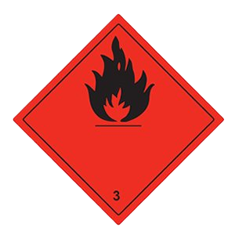
15 | SECTION 15: Regulatory information:
15.1 Safety, health and environmental regulations/legislation specific for the substance or mixture:
Water hazard class, WGK (AwSV): 1
Volatile organic component (VOC): 78.000 %
Volatile organic component (VOC): 628.836 g/l
Composition by regulation (EC) None 648/2004:
15.2 Chemical Safety Assessment:
No data available
16 | SECTION 16: Other information:
Legend to abbreviations used in the safety data sheet:
ADR: | The European Agreement concerning the International Carriage of Dangerous Goods by Road
ATE: | Acute Toxicity Estimate
BCF: | Bioconcentration factor
CAS: | Chemical Abstracts Service
CLP: | Classification, Labelling and Packaging of chemicals
EINECS: | European INventory of Existing commercial Chemical Substances
LC50: | median Lethal Concentration for 50% of subjects
LD50: | median Lethal Dose for 50% of subjects
Nr.: | Number
PTB: | Persistent, Toxic, Bioaccumulative
TLV: | Threshold Limit Value
vPvB: | very Persistent and very Bioaccumulative substances
WGK: | Water hazard class
WGK 1: | Slightly hazardous for water
WGK 2: | Hazardous for water
WGK 3: Extremely hazardous for water
Legend to the H Phrases used in the safety data sheet:
H225 Flam. Liq. 2: Highly flammable liquid and vapour. H319 Eye Irrit. 2: Causes serious eye irritation.
H336 STOT SE 3: May cause drowsiness or dizziness.
CLP Calculation method:
Calculation method
Reason of revision, changes of following items:
Not applicable
SDS reference number: ECM-111763,00
This safety information sheet has been compiled in accordance with annex II/A of the regulation (EU) No 2015/830. Classification has been calculated in accordance with European regulation 1272/2008 with their respective amendments. It has been compiled with the utmost care. We cannot, however, accept responsibility for damage, of any kind, that may be caused by using these data or the product concerned. To use this preparation for an experiment or a new application , the user must carry out a material suitability and safety study himself.

